Challenge 2: Demonstrate the performance of a voltage divider circuit and a Wheatstone bridge circuit.

**Student Learning Outcomes:**

1. Measure DC voltage, resistance, and current with a true RMS multimeter
2. Interpret resistor codes to determine nominal resistance value
3. Compare nominal resistor values with measured resistance
4. Construct simple analog circuits on a breadboard with DC power supply

**Pre-Lab:** Read the files provided on iLearn to ensure you are ready to take on the Lab Challenge 2. These files include user manuals for the multimeter and power supply benchtop instruments, as well as files that detail resistance and capacitor codes. It is strongly suggested that you review equations from your ECE Circuits course to ensure you can predict values for current, voltage, and resistance in a circuit.

Lab Guidance (You determine the experiment design and process):

Notes: (1) In this and all subsequent measurements, be sure to record the data to the highest precision available from the instrument. (2) Use the measured values for resistance in all subsequent calculations instead of the nominal values.

Activity 1) Series and Parallel Resistor Circuit, acting as a voltage divider

Study the diagram and then construct the series-parallel resistive circuit shown. First predict what you think will happen, by developing analytical equations in parametric form.

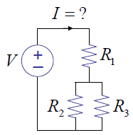

Suggested process: modify as needed

* Be sure to take resistance readings with the circuit power source, V, off.

Measure R1

Measure R2

Measure R3

Measure R bc =

Measure R ac =

Locate resistors R1, R2, and R3. Document their color codes. Measure the resistance of each resistor and record the results. Determine the percent difference between the measured value and the nominal value. Measure across the parallel set of resistors (R2 and R3), then across the total set of resistors (R1, R2, and R3).

*Observe and Discuss:* Compare your analysis and expected value(s) with what you measure.

Using the digital DC power supply, connect an input voltage of V volts to the circuit above (across points a and c). Measure the voltages Vab and Vbc across the points indicated.

*Observe and Discuss:* Compare your analysis and expected value(s) with what you measure.

Measure the current in the circuit at node a. ***Be sure to insert the multimeter in SERIES with the circuit!!***

*Observe and Discuss:* Compare your analysis and expected value(s) with what you measure.

**Activity 2) Wheatstone Bridge Circuit**

Analyze and then construct the circuit shown with the indicated nominal R1, R2, R3, R4 values assigned. Calculate and measure the voltage across BC for each version of the circuit, Q1 and Q2.

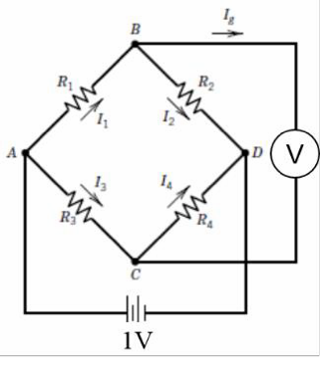

|  |  |  |  |  |  |  |
| --- | --- | --- | --- | --- | --- | --- |
|  | | | | | **Calculation** | **Measurement** |
| **Q#** | **R1**  **[kΩ]** | **R2**  **[kΩ]** | **R3**  **[kΩ]** | **R4**  **[kΩ]** | **V [V]** | **V [V]** |
| **1** |  |  |  |  |  |  |
| **2** |  |  |  |  |  |  |

**Data Analysis:**

* In the spreadsheet, be sure to include raw data you measured for each activity and compute percent differences between nominal and/or calculated values and measured values

**Deliverables:**Refer to Challenge 1 and/or the iLearn site to see general format